Year 5 and 6 pupils visit Wrens Nest Nature Reserve for geographical field work and to learn historical local history knowledge about fossils.

Key historical and geographical texts are used in each year group.

Subject leaders carry out pupil conferences with pupils to talk about their history and geography learning.

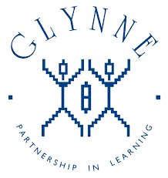

Children in Year 3 to Year 6 have the role of Subject Ambassadors to champion their subject and share their thoughts about history and geography throughout school.

All year groups have historical theme days and dress up.

We explore our local area through humanities studies that are linked to learning journeys.

We become immersed in a historical time period or location by ensuring classrooms replicate the journey.

Humanities subject leaders complete annual action plan which is reviewed and shared with governors.

High standards of historical and geographical writing.

Visitors are invited into school to enrich learning.

Year 5 and 6 visit Tudor World and join the Shakespeare Stratford tour.

We have geography and history focus days in school.

Book trawls and monitoring carried out by subject leaders and feedback given.

Year 3 and 4 children visit Blists Hill Victorian museum.

Year 1 and 2 go to Dudley Castle as part of their Local Area Study.

Glynne Primary School

What does

history and geography look like?

Forest School for all children.

Each year group has a learning journey that is driven by a historical or a geographical focus.

Year 6 children attend a 2 night residential to PGL.

Year 1 and 2 children visit the woods to complete field work as part of their learning.

Learning Journeys provide lots of opportunities for

cross- curricular learning.